PRACTICAL WEEK 4
Task-1 Write a C program where a parent process creates multiple child processes and synchronizes their completion using wait() and waitpid(). Compare the both functions
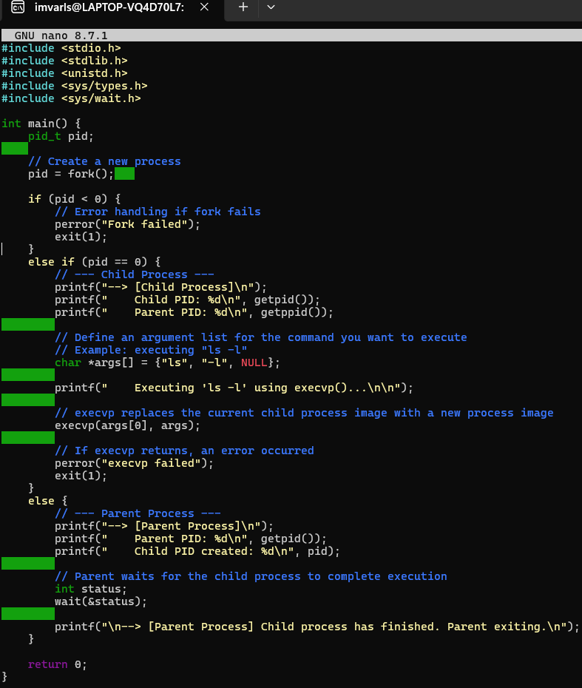
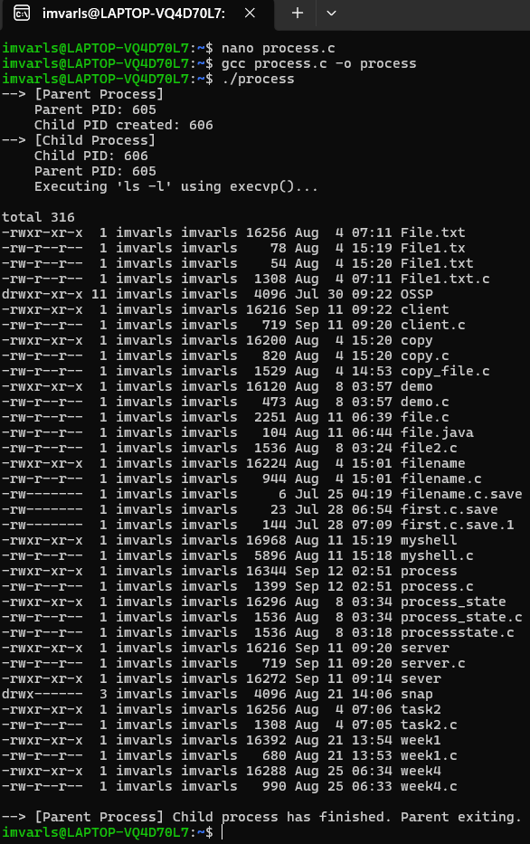
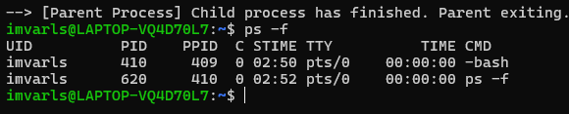

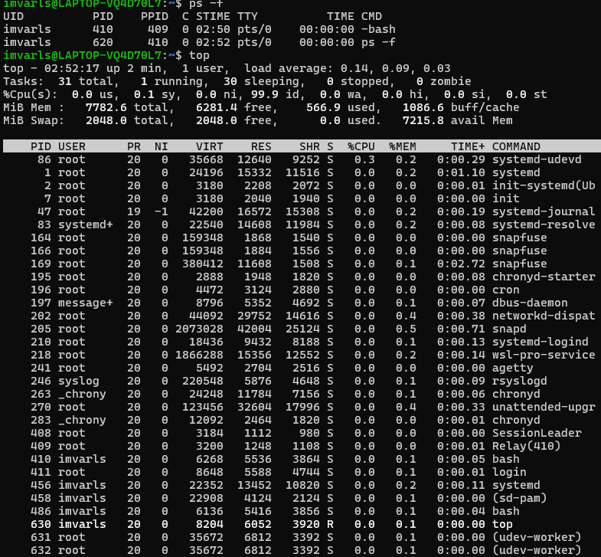
Observation
● The parent process successfully created three child processes usingfork().
● Each child process executed independently and terminated after a different delay.
● The wait() function waited for any one child process to complete and returned the PID of the completed child.
● The waitpid() function waited for a specific child process using itsPID
● The parent process synchronized with all child processes before terminating.
● Thus, wait() provides general child-process synchronization, whilewaitpid() provides more specific control over which child process waited for.

Task-2 Create a scenario where a child process becomes a zombie process. Investigate the process table and then modify the program to eliminate zombie processes using proper synchronization techniques.

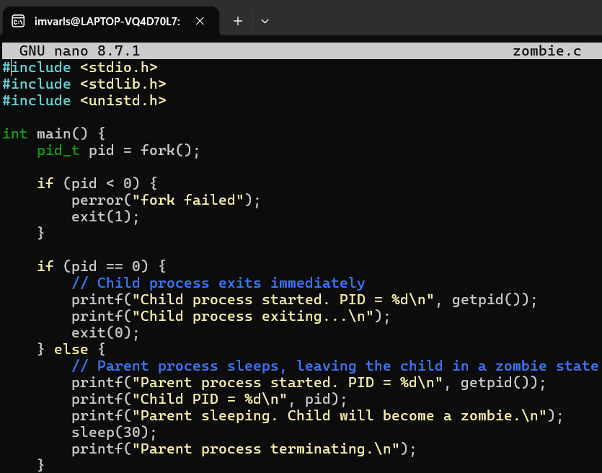

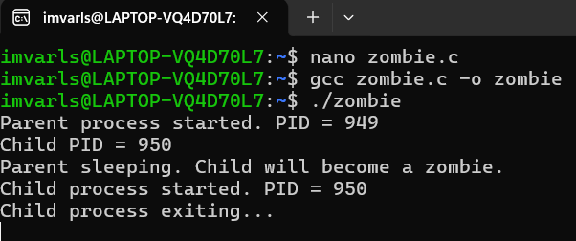

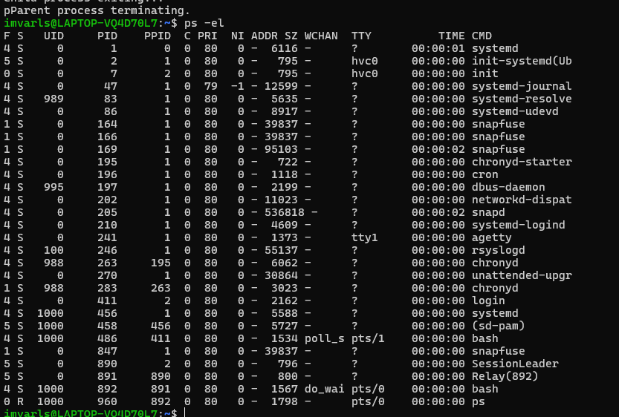

Observation
● A child process was created using fork().
● The child terminated while the parent continued executing without calling wait() or waitpid().
● The terminated child remained in the process table as a zombie (Z) /process because its exit status had not been collected by the parent.
● The program was then modified to use waitpid() for proper synchronization.
● After the modification, the parent collected the child's exit status immediately after its termination.
● The child was therefore removed from the process table and no zombie process was created.
● This demonstrates that proper parent-child synchronization using wait() or waitpid() prevents zombie processes.

